1. **Pictures from project**

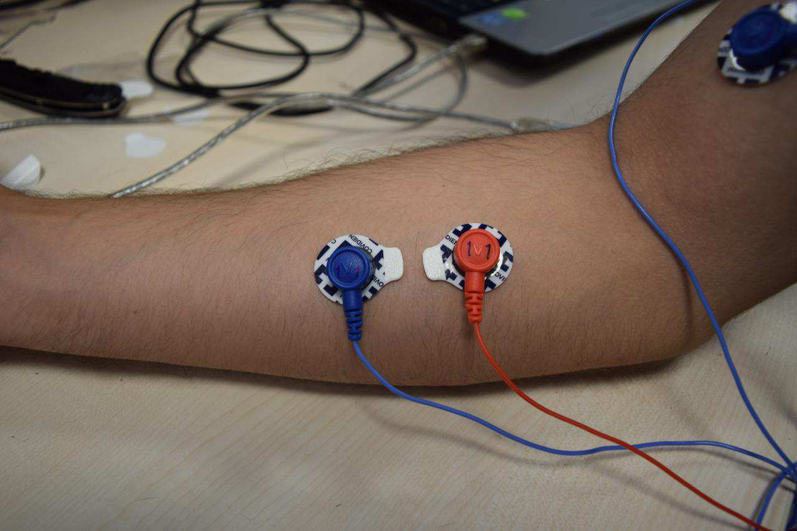

**Figure**. Electrodes placed on forearm

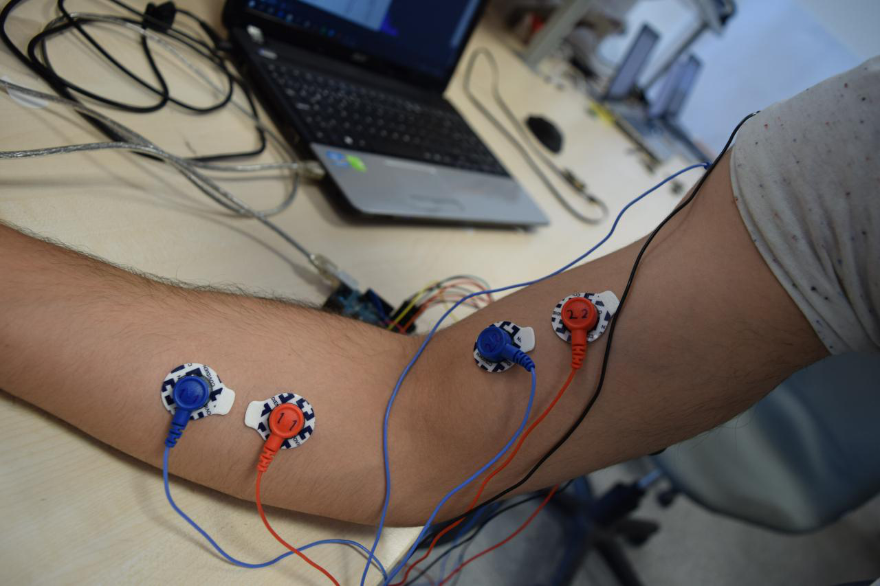

**Figure.** Electrodes placed on biceps and forearm

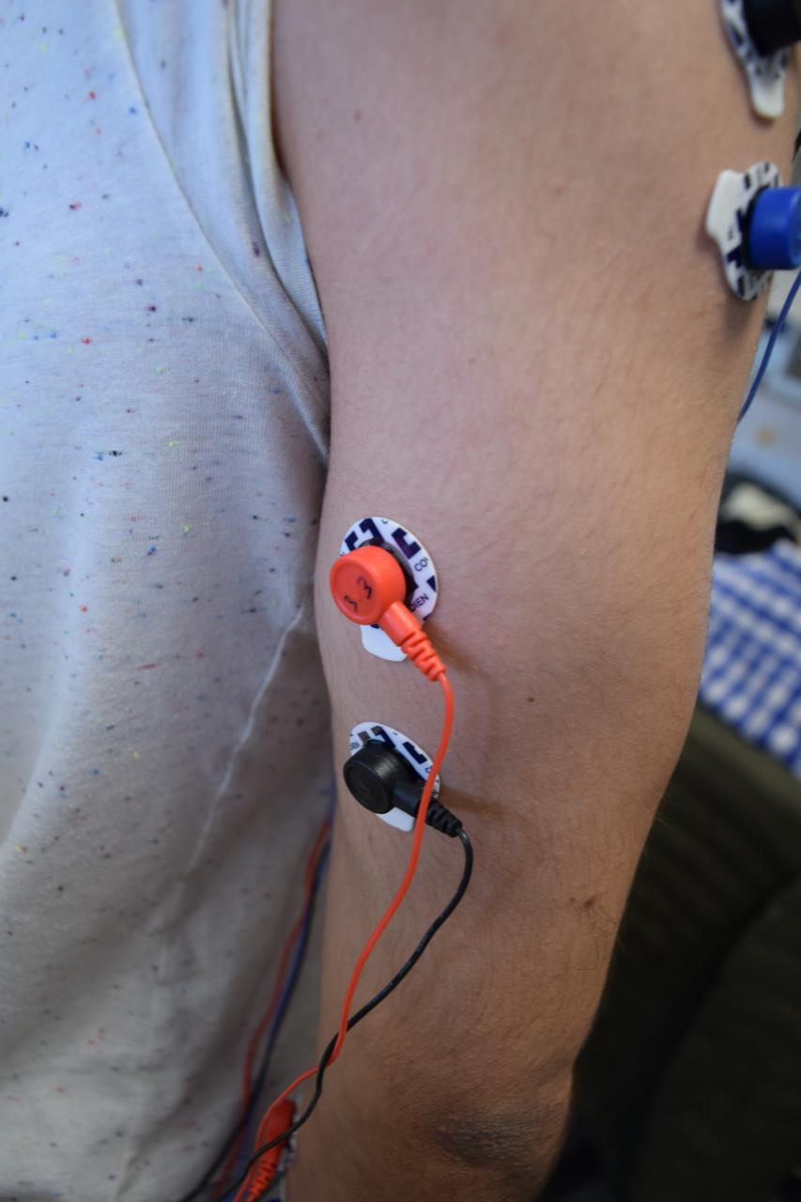

**Figure.** Electrode placed on triceps

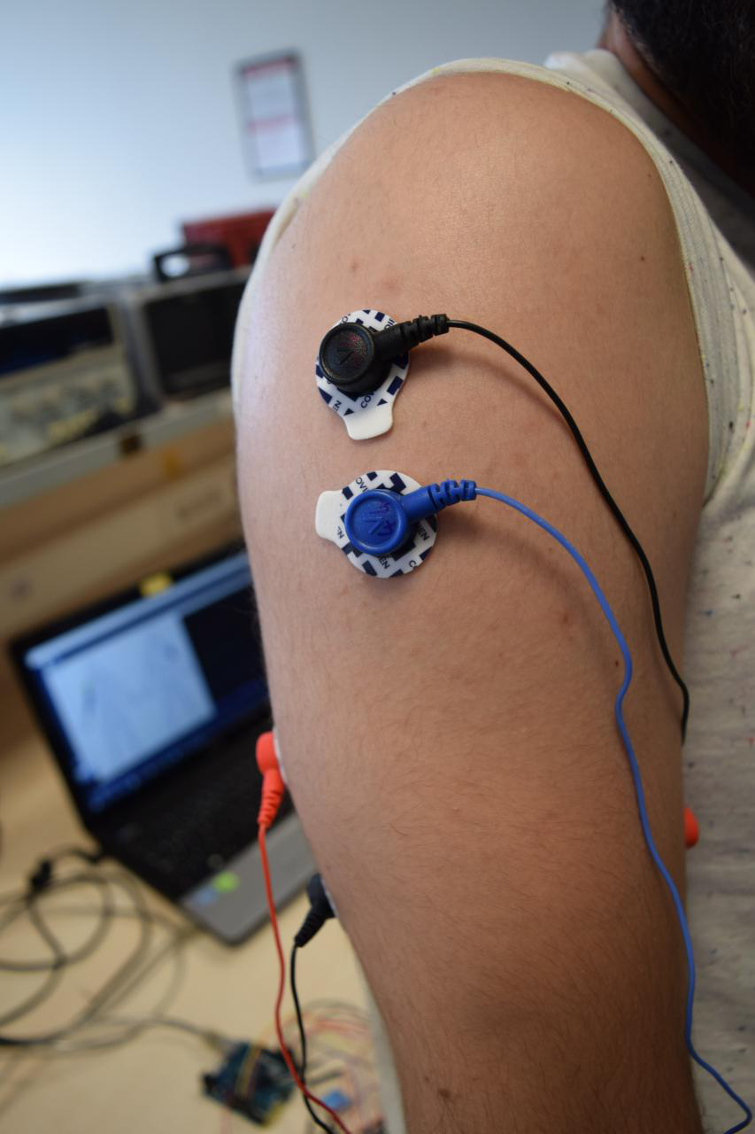

**Figure.** Electrodes placed on shoulder

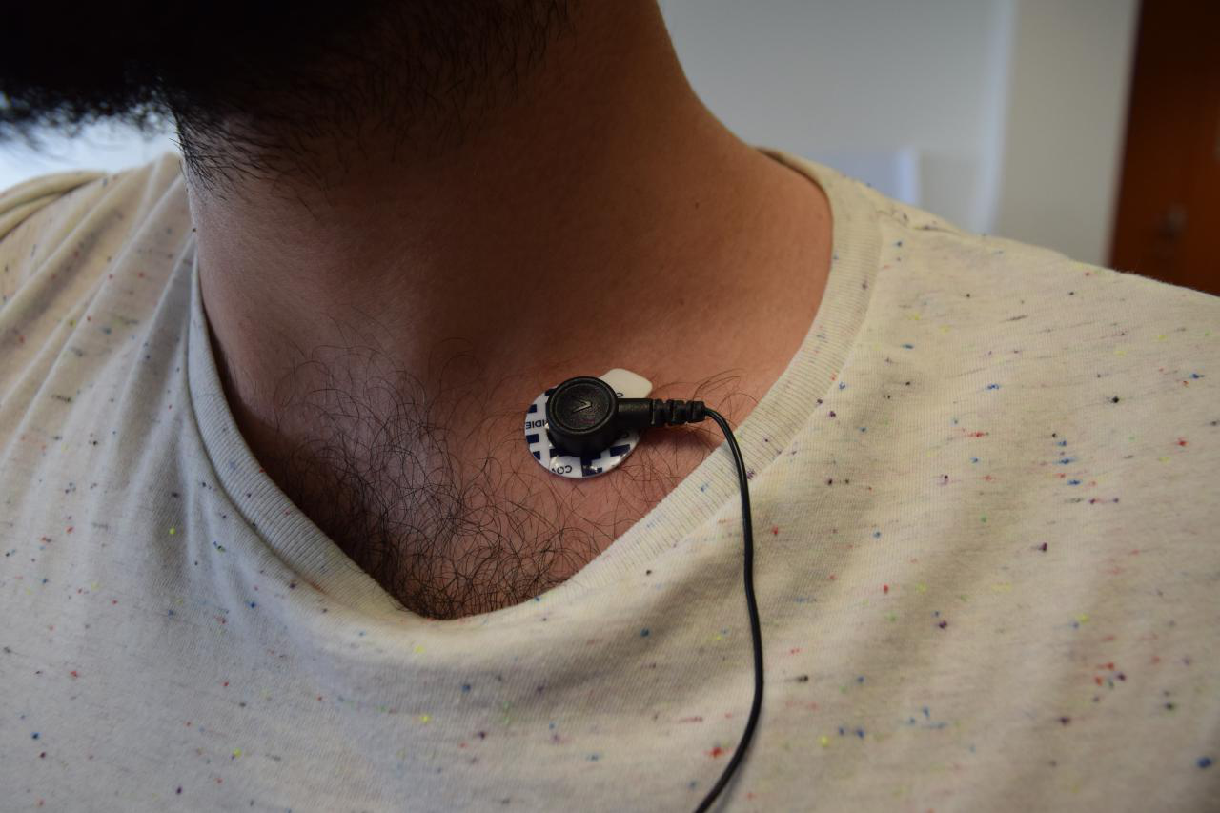

**Figure.** Reference electrode placed on bony part of chest

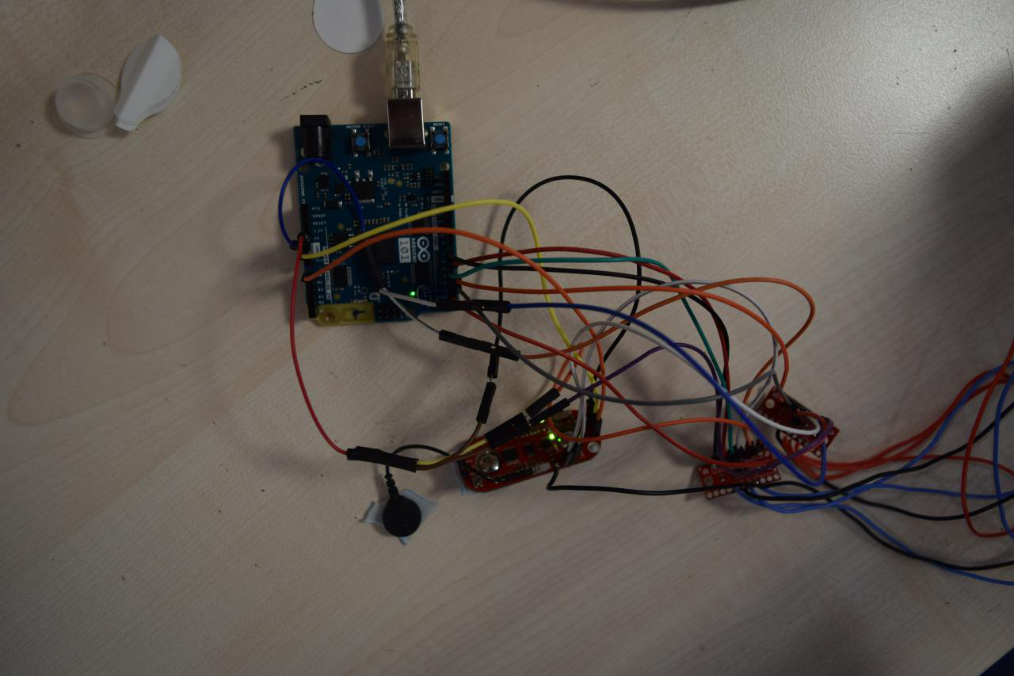

**Figure.** General picture of hardware of the project